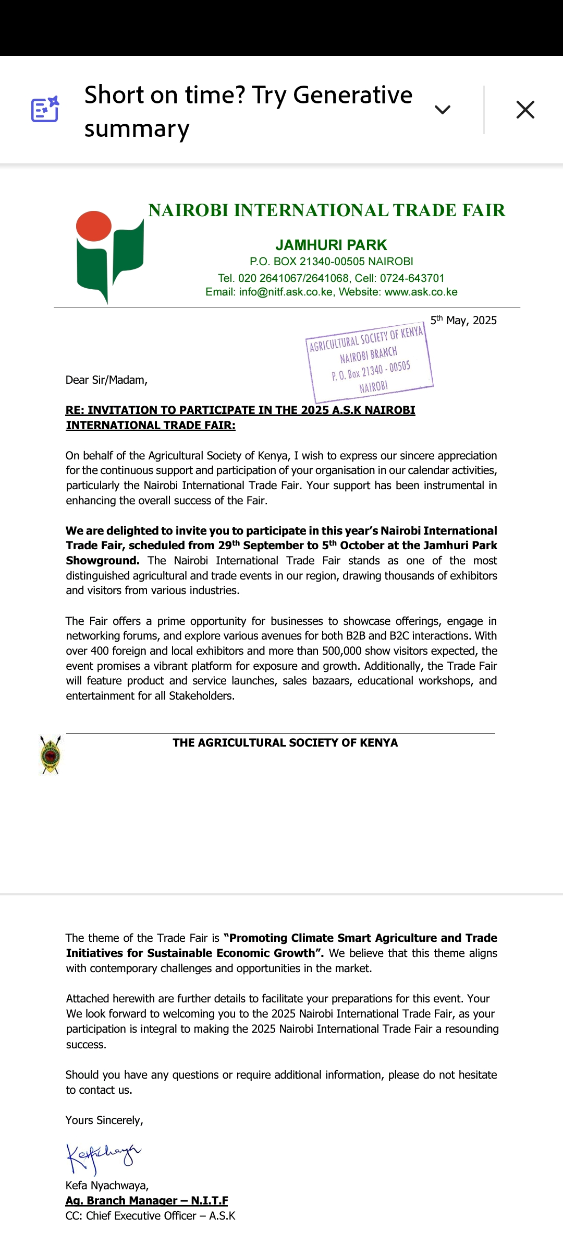

***Our Ref:*** ASK/NITF/Vol II/035/25 10th July 2025

The Group Chief Executive Officer,

Kenya Tea Development Agency (Holdings) Limited,

P.O. Box 30213 – 00100,

**NAIROBI**

Dear **Bwana CEO,**

**RE: INVITATION TO PARTICIPATE IN THE 2025 A.S.K NAIROBI INTERNATIONAL TRADE FAIR:**

On behalf of the Agricultural Society of Kenya, I wish to express our sincere appreciation for the continuous support and participation of your organisation in our calendar activities, particularly the Nairobi International Trade Fair. Your support has been instrumental in enhancing the overall success of the Trade Fair.

**We are delighted to invite you to participate in this year’s Nairobi International Trade Fair, scheduled from 29th September to 5th October at the Jamhuri Park Showgrounds.** The Nairobi International Trade Fair stands as one of the most distinguished agricultural and trade events in our region, drawing thousands of exhibitors and visitors from various industries.

The Fair offers a prime opportunity for businesses to showcase offerings, engage in networking forums, and explore various avenues for both B2B and B2C interactions. With over 400 foreign and local exhibitors and more than 500,000 show visitors expected, the event promises a vibrant platform for exposure and growth. Additionally, the Trade Fair will feature product and service launches, sales bazaars, educational workshops, and entertainment for all Stakeholders.

The theme of the Trade Fair is **“Promoting Climate Smart Agriculture and Trade Initiatives for Sustainable Economic Growth”.** We believe that this theme aligns with contemporary challenges and opportunities in the market.

Attached herewith are requisite documents with relevant details to facilitate your confirmation and preparations for this event. We look forward to hosting your organization during the 2025 Nairobi International Trade Fair, as your participation is integral in making the 2025 Nairobi International Trade Fair a resounding success.

Should you have any questions or require additional information, please do not hesitate to contact us.

Yours **Sincerely,**

Kefa Nyachwaya,

**Ag. BRANCH MANAGER – N.I.T.F**

CC: Chief Executive Officer – A.S.K

# FORM TITLE: EXHIBITOR PARTICIPATION FORM



**THE AGRICULTURAL SOCIETY OF KENYA**

**2025 NAIROBI INTERNATIONAL TRADE FAIR EXHIBITOR FORM**

**DATE: 29TH SEPTEMBER – 5TH OCTOBER 2025**

**PLEASE COMPLETE THE FORM IN DUPLICATE AND RETURN THE ORIGINAL TO THE BRANCH MANAGER, NAIROBI INTERNATIONAL TRADE FAIR.**

**P.O BOX 21340-00505 NAIROBI, E-mail: trade@nitf.ask.co.ke**

**PARTICIPATION IN THE NAIROBI INTERNATIONAL TRADE FAIR**

THIS FORM SHOULD BE RETURNED BY 31/07/2025

**We wish to exhibit** during the 2025 Nairobi International Trade Fair.

**We do not wish to exhibit** during the 2025 Nairobi International Trade Fair.

**PART A: EXHIBITOR DETAILS**

Exhibitors Name: **…………………………………………………………………………………………..........**

Stand /Plot. No (If known)……………………………….……………................................................................

Open Space location…………………………………….….………………………………………..…..…..……………...........

Country of Origin……………………………………….……………………………………………….…………………..............

Contact person 1…………………………….………………Designation……………............Mobile……………………….

Contact person 2…………………………….………………Designation..........…………….Mobile……….……………….

Physical Address………………………………………………………………….………………..……………..…..…….. ……....

....................................................................................................................................................

Postal Address……………………………………………………Code……………………City……….……..…….….…..........

Telephone (Mobile No) ………………………………………Fixed Line (Telephone)……………………………………....

Email Address….…………………………………………………………………………………………….………….……….........

Website Address………………………………………………………………..……………………………….…..………….........

Residence in Kenya (For international Exhibitors)………………… ………………………………………………..........

Date …………………………………….......................Signature…..……………..……………………………………........

## FORM TITLE: EXHIBITOR PARTICIPATION FORM

**PART B: OTHER DETAILS**

1. Are you exhibiting for the first time in Nairobi International Trade Fair? (Tick One)

Yes No

1. If the answer to 1 above is yes, how did you receive the information about the trade fair…………………………………………………………………………………………………….
2. In which category are your products or services? (Trade, Manufacturing, Agricultural, Services etc. Please specify) ……………….………………………………………………........................................................
3. List some of the products/services that you will be exhibiting.

………………………………………………………………………………………….……………………………….........................

………………………………………………………………………………..…………………………..…………….........................

1. List the new technologies that you will be show casing

i. …………………………………………………………………………

ii. …………………………………………………………………………

iii. ………………………………………………………………………….

1. Do you need to bring in fresh supplies every morning? If yes, which supplies?

...................................................................................................................................................

**PART C: FOR OFFICIAL USE ONLY**

Your application to retain/be allocated Block / Stand/ Plot No …………………….of size…................. (sq.ft / sq.m)

Is  Approved  Not Approved

Trade Officer……………………………………………..……............. Signature…………………..........Date…………….........

Amount for stand/plot……………………………………………………….………………………………….................................

Confirmation by Branch Accountant………………………..........Signature….…………................Date….................

Remarks…………………………………………………..………………………………………………….........................................

Approved by Branch Manager…………………………………Signature………..……..................Date………………….......

Chairman Trade…....................................................... Signature.....................................Date...........................



**20**

**2**

**5**

**EXHIBITION BOOKING FORM**

**-**

**INDOOR**

**SPACES**

**NAIROBI INTERNATIONAL TRADE FAIR**

**29**

**th**

**September**

**–**

**5**

**th**

**October**

**20**

**2**

**5**

(

Monday

-

Sunday)

FORM NO: ASK/INV/1

/2025

Theme: “***Promoting Climate Smart Agriculture and Trade Initiatives for sustainable economic growth***”

**1. Company Information**

Company Name ____________________

Physical Address__ _________________________________________________________

City & Country_ Postal Address________ _______________________

Website ___________ ___________________________Department___ ______

Tel _________________Mobile__________________Email___________________________________

Contact Person ___ __________________Title___________ _____

## 2. Permanent Stand Charges

**Stand Location/Plot No**. : KShs

**Trade Rent** : KShs _____________________________

**Branding :** KShs **_____________________________**

**Water and Utility fee** : KShs**_____________________________**

**16% VAT :** KShs**_____________________________**

## Sub Total : KShs_________________________________

### 3. Display Booth Selection & Charges

I would like to reserve (a) booth(s) in the Jamhuri Expo Centre and/or Global Traders Pavilion

|  |  |  |
| --- | --- | --- |
| All pricing for a 10ftx10ft booth is $ 2,000 for international exhibitors & Kshs. 174,000/= (VAT incl) local exhibitors at the **Jamhuri Expo Centre**.  All pricing for a 10ftx10ft booth is $ 450 for international exhibitors &  Kshs. 52,200/= (VAT Incl) local exhibitors at the **Global Traders’ Pavilion Block 1 and 2** | **Quantity** | **Subtotal** |
| Number of booths required |  |  |
| Preferred Location |  |  |

## 4. Open Space Charges

|  |  |  |  |  |  |
| --- | --- | --- | --- | --- | --- |
| **CENTRAL BUSINESS DISTRICT (CBD)** | | **Tick** | **OFF CENTRAL BUSINESS DISTRICT** | | **Tick** |
|  |  | **here** |  |  | **here** |
| 10 FEET X 10FEET - | 115,000 |  | 10 FEET X 10FEET | - 85,000 |  |
| 15 FEET X 15 FEET - | 202,500 |  | 15 FEET X 15 FEET | - 165,000 |  |
| 25 FEET X 25 FEET - | 265,000 |  | 25 FEET X 25 FEET | - 215,000 |  |
| 50 FEET X 50 FEET - | 327,500 |  | 50 FEET X 50 FEET | - 265,000 |  |
| 75 FEET X 75 FEET - | 390,000 |  | 75 FEET X 75 FEET | - 315,000 |  |
| 90 FEET X 90 FEET - 452,500 | |  | 90 FEET X 90 FEET - 365,000 | |  |

**ALL CHARGES ARE VAT EXCLUSIVE**

Stand Location/Plot No_________________________Sub Total

|  |  |  |
| --- | --- | --- |
| **5. Membership Information and** | **Charges** |  |

**I would like to Subscribe for ASK Membership**

Membership badges that facilitate entry to the showground are currently on sale at our accounts offices at Jamhuri Park. The categories are as follows: -

|  |  |
| --- | --- |
| Badge Category (Please tick as appropriate) | Quantity Required |
| ❖ Executive Badge (Ksh 8,500/=) | ___________________ |
| ❖ Full member badge (Kshs. 3,000/=) | ___________________ |
| ❖ Single member badge (Kshs. 2,000/=) | ___________________ |
| ❖ Kenya Ploughing Organization (KPO) badge – (Kshs. 2,000/=) | ___________________ |
| **6. Application for Judging of Stand** |  |

Exhibitors are encouraged to enter for judging classes. The list of classes can be obtained from <http://www.ask.co.ke/branch-events/international-shows/nitf/participation>and Exhibitors can fill in judging forms through [http://www.ask.co.ke/resources/judging-form.](http://www.ask.co.ke/resources/judging-form)

**7. Ticket and Passes**

I/we would like to request for tickets;

Tickets will be available at the beginning of September 2025 and can be purchased online or at the perimeter gates.

Adult (Kshs. 350 per day) Quantity __________________

Child (Kshs. 300 per day)Quantity __________________

### 8. Partnership Opportunities

Below are the various partnership opportunities, contact us for more information:

* Media coverage & Publicity- Inclusion of your organization in our media coverage and publicity drives.  Roadshows- joint roadshow activities.
* Harvest Festival and CSR activities- Participation in our Corporate Social Responsibility activities.
* Logo on the show entry tickets- Inclusion of your company logo on our show entry tickets.
* Branding – Branding of Walls, Gates, Roofs, Bins, Directional Boards within the showground to increase your brand visibility during the trade fair week.
* Advertising your company in the show catalogue and Arena programme.
* Advertising on LED Screens within the showground during the trade fair week.
* Hire of grounds and facilities- Hire of our grounds and facilities for your specialized shows, expositions and corporate events etc.
* Ploughing Contest- Participating in the Nairobi Branch Ploughing Contest to increase your brand awareness.
* Hire of showground facilities for personalized events.

### 9. Payment Schedule

Acceptable modes of payments;

* Direct deposit to our bank account at KCB, Kipande House Branch; **EFT Swift Code KCB LKENX account number 1103870254**
* **Bankers cheque** drawn in favour of **“A.S.K NAIROBI BRANCH”** OR
* **MPESA paybill** number **996882. Account name** is your company name**.**

50% deposit will be required as booking fee and the remaining amount should be settled by 15th September 2025

**FULL PAYMENTS MUST BE MADE BEFORE THE COMMENCEMENT OF THE TRADE FAIR.**

### 10. Company Authorization

The undersigned hereby makes application for exhibition space and agrees to abide by Terms and Conditions on this booking form as well as the Rules and Regulations accessible from:

[**http://www.ask.co.ke/branch-events/international-shows/nitf/exhibitor-s-rules-and-regulations.**](http://www.ask.co.ke/branch-events/international-shows/nitf/exhibitor-s-rules-and-regulations)

This agreement is effective on the date signed below and will remain in effect until 10th October 2025.

Name___________________________________________________________________

Signature___________________________________ Date__________________________

**Contacts**

For more inquiries, contact:

The Branch Manager, Nairobi International Trade Fair,

Telephone Numbers: +254 724 643701 / +254 769 064 791

Email address – trade@nitf.ask.co.ke copied to marketing@nitf.ask.co.ke; info@nitf.ask.co.ke

***Thank you for reserving exhibition space at the NITF.***