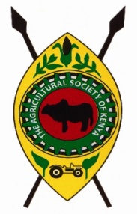

**THE AGRICULTURAL SOCIETY OF KENYA**

**BARINGO BRANCH SHOW, P.O. BOX 229 – 30400, KABARNET**

**EMAIL:** [**kabarnet@ask.co.ke Tel**](mailto:kabarnet@ask.co.ke%20Tel) **0721 769 899/0728 542 700**

**....................................**

**....................................**

**.................................**

Dear Sir/Madam,

**RE: PARTICIPATION AND PARTNERSHIP DURING THE 2024 BARINGO BRANCH SHOW**

On behalf of the Baringo Show organizing Committee, I take this opportunity to extend our sincere gratitude to **Egerton University** foryour continued support and participation in the Baringo Branch Show over the years. The Baringo Show is scheduled for 19th to 21st September, 2024.

We have lined up several activities during the Show among them being various exhibitions specializing in agronomy, animal health, machinery, service industry and government institutions among others.

In this regard, the Branch kindly requests for your partnership by Branding/Painting either the Gates, Walls, Arena roofs at the Showground as per the attached rate card with your brand colors to enhance your visibility within the showground.By branding; your company visibility is increased during the show which attracts over 50,000 show goers and after the show where we continue to host sports activities and other events throughout the year.

Your kind consideration on any of the above will be highly appreciated.

Yours Faithfully,

**ISAAC CHEMNG’OREM**

**BRANCH CHAIRMAN**

CC: Branch Manager